**Data Analytics Portfolio Project**

**Supply Chain Management**

**Project Team: Group K**

Zaheer Abbas

Zahid Hussain

Zawar Ali Gillani

**Date: 20-08-23**

1. **Data Dictionary:**

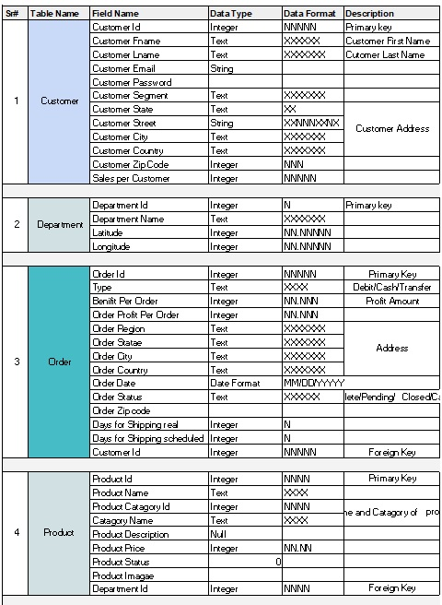

1. **Database Link / Folder:**

**Database:**https://drive.google.com/drive/folders/1bHNQYWzBb71l6iz16c_XiQUYmtdwOmy3?usp=drive_link

**Folder:** Supply chain data

1. **Detailed Report Document:**

Supply chain data

1. **Stakeholders:**
2. **Supply Chain Managers:**

The late delivery analysis will help the managers to improve shipping processes and reduce late delivery risks.

1. **Sales and Marketing Teams:**

They would benefit from the RFM analysis to make marketing strategies and promotions to different customer segments.

1. **Finance Team:**

They are interested in profit analysis, especially how late deliveries impact profitability.

1. **Product Managers:**

Insights will make them able to make decisions about inventory and product offerings.

1. **Customer Service Representatives:**

wanted to take benefit from understanding customer segments and their behaviours to provide better assistance.

1. **Executives and Decision Makers:**

To use market analysis and other insights to make strategic decisions for upliftment of business.

**Executive Summary:**

This report presents a comprehensive analysis of sales trends within our supply chain organization. By examining historical sales data from 2015 to 2018, we aim to identify the factors contributing to a decline in sales and profit ratios. We will also provide recommendations to address these challenges and outline the potential impact of implementing these remedies.

1. **Sales Trends Overview:**

From 2015 to 2016, sales were consistently around 50 million units, with a stable profit ratio of 11%. However, a significant decline was observed in 2018, with sales plummeting to 23 million units and a corresponding drop in the profit ratio to 9%. This prompts us to delve into potential causes behind this drastic change.

1. **Factors Behind the Decline:**
2. **Market Changes:** A changing market landscape, shifts in customer preferences, and evolving industry trends might have impacted demand for our products.
3. **Product Performance:** A detailed analysis of product-level sales reveals whether specific products or categories experienced a more pronounced decline in sales and profit ratios.
4. **Supply Chain Efficiency:** Shipping delays, late delivery risks, and discrepancies between real and scheduled shipping days may have contributed to customer dissatisfaction and reduced sales.
5. **Pricing Strategies:** Inconsistent pricing and discounting might have influenced customer purchasing decisions and overall profitability.
6. **Customer Satisfaction:** Delivery and order status could reflect customer satisfaction levels. A drop in satisfaction may lead to decreased repeat business and negative word-of-mouth.

**Objective:**

To enhance the efficiency, effectiveness, and overall performance of the supply chain management process through data-driven insights. The insights derived from the dataset can help achieving numerous goals like to put a halt to shrink of sales and profit ratio, to garner customer satisfaction to bring back their confidence in organization and to identify the quality customers/customer segment by performing RFM analysis.

**ERD**

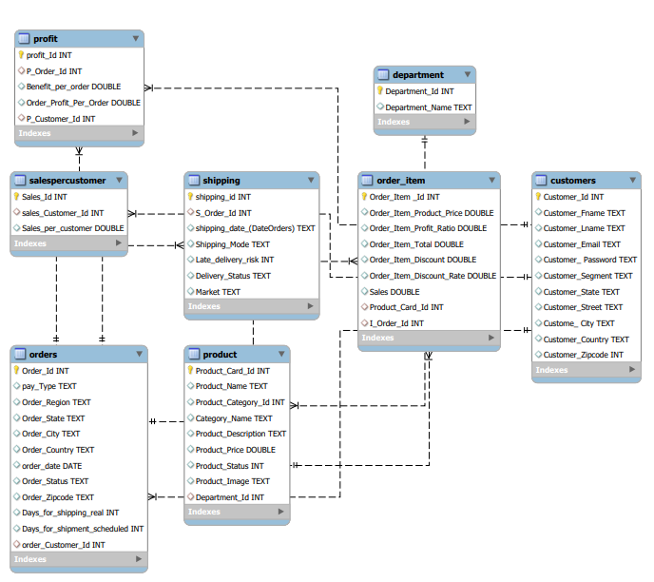

**Key Problems:**

* Is there any change in the market demand?
* Which products or product category experienced the most significant decline in sales and profit ratio.
* Can late delivery risk lead to customer dissatisfaction, reduced repeat business, and lower sales? How often late deliveries occur?
* How different customer segments contribute to sales and profit? RFM analysis.
* Does shipping mode affect the profitability?
* Which product categories are least and most profitable?
* Which city/state/country has placed maximum orders?
* Which city/state/country has generated maximum profit?
* What is the trend of profit of shipment of products in different regions?
* Which market generates maximum profit (pacific Asia, Europe etc)?
* Does order status (pending, Cancel, pending-payments, suspected-fraud) have an impact on profit/loss?
* Does the mode of shipping impact delivery status?
* Does the mode of payment (Type) have any impact on profit?

**Objectives and Approach:**

1. **RFM analysis**: identify quality customers.
2. **Market Demand Analysis:** Determine if market demand has changed and identify factors influencing demand shifts.
3. **Product Performance Analysis:** Identify products or product categories with significant sales and profit declines to strategize improvements.
4. **Delivery Impact Analysis:** Assess the impact of late deliveries on customer satisfaction, repeat business, and sales frequency.
5. **Customer Segmentation Analysis:** Utilize RFM analysis to understand how different customer segments contribute to sales and profitability.

**Define objective:**

Analyse supply chain data to improve profitability. Identifying the different factors have a significant impact on profit or cost.

**Data Analysis Process / Approach:**

**Data modelling**

To break the dataset in number of sheets to import tables accordingly.

**Data cleaning**

* To handle missing values, outliers, and inconsistencies in the dataset.
* Converting date-related fields into appropriate date formats.
* To check for duplicates and remove redundant data.

**Exploratory data analysis:**

Understanding sales trends, identifying factors contributing to decline, and suggesting remedies.

**Data Exploration:**

* Explore change in market demand.
* Explored products or product categories with highest sales and profit ratio.
* Analyse the late delivery impacts.
* Identified customer segments and their contribution in sales and profit.
* Analyse shipping mode over profit.
* Identify profitable product categories.
* Analyse the city/state/country with respect to orders and profit.
* Explore the regions with highest profits.
* Identify profitable markets.
* Explore order status on profit.
* Analyse shipping mode impact on delivery status.
* Explore the relation between payment mode and profit.

SQL Queries: (Queries Screenshot or Queries Syntax)

Querry 1: Late Delivery Risk Count.

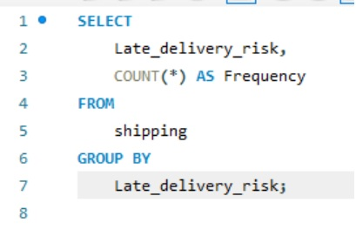

Querry 2: Late Delivery Status.

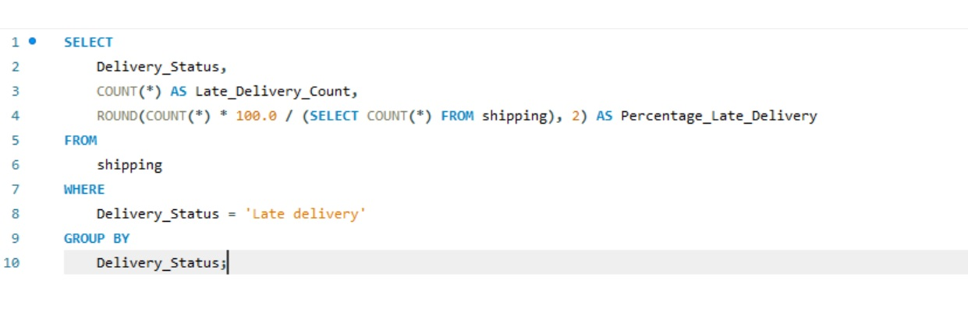

Querry 3: Late Delivery Risk with respect to Product Categories.

Querry 4: Different Customer Segments Contributing to Sales and Profit.

Querry 5: RFM Analysis.

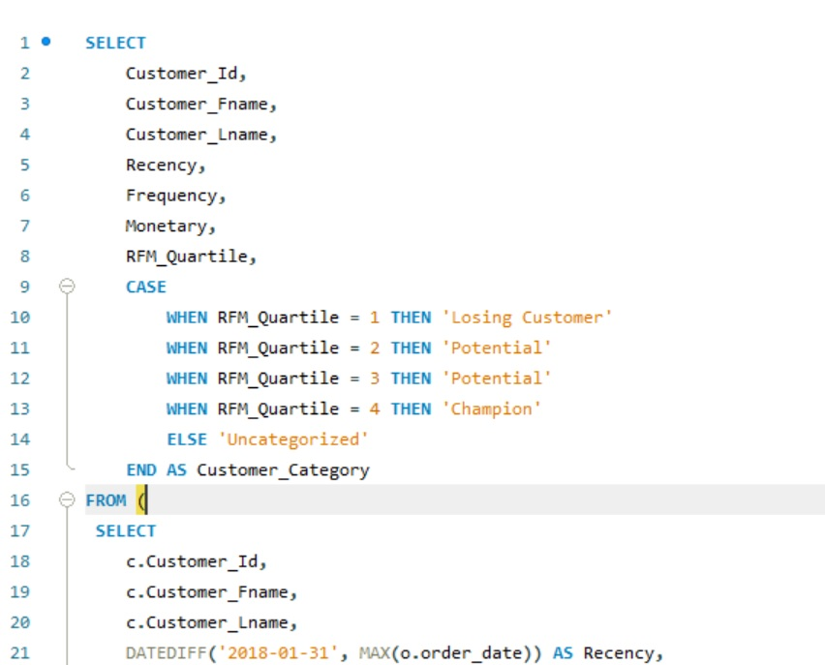

Query 5: Total Profit Generated by Different Shipping Modes.

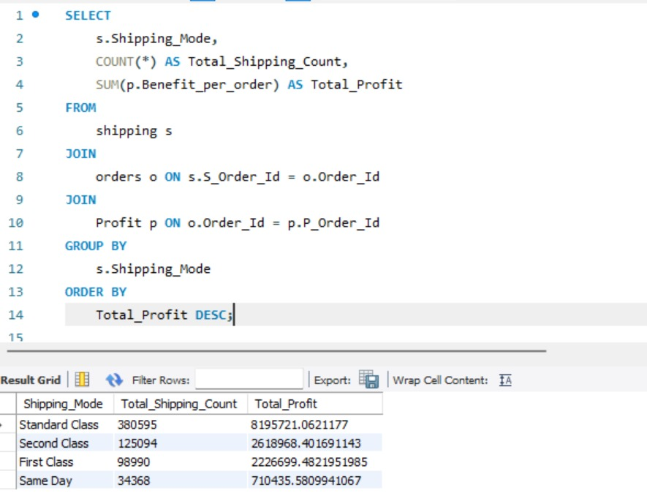

Querry 6: Delivery Status of Different Shipping Modes.

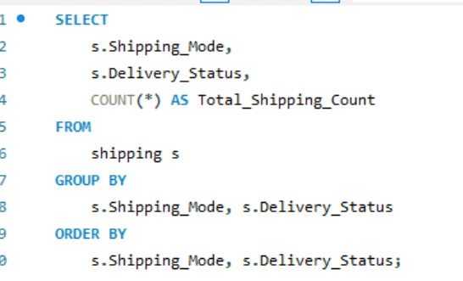

Visualization, Results, and Insights:

1. **Late Delivery Count and Frequency:**

The analysis shows that maximum late deliveries occurred in Central America that makes a total of 21.24% whereas minimum late deliveries occurred in West USA which is only 5.90% of the total.

This graph represents Late Delivery counts with respect to the order region.

In case of product category, the minimum late deliveries occurred in golf balls that is 0.7% and maximum late deliveries were of Cleats making up to 21.65% of the total late deliveries.

This graph represents late deliveries along with product category.

Analysis shows that 55% of the total deliveries were consistently arriving late. This indicates a significant issue within the delivery process that demands critical attention.

This graph represents frequency of late deliveries.

1. **Analysis of Modes of Shipping:**

Out of the 180516 orders, 7,754 (4.3%) were cancelled and 172,762 (95.7%) were shipped through different modes. Among the shipped orders 57.29% were late, 8.22% were on time and 24% were advance shipments. In the first class all the shipping were either late or cancelled whereas advance shipping happened only in standard class.

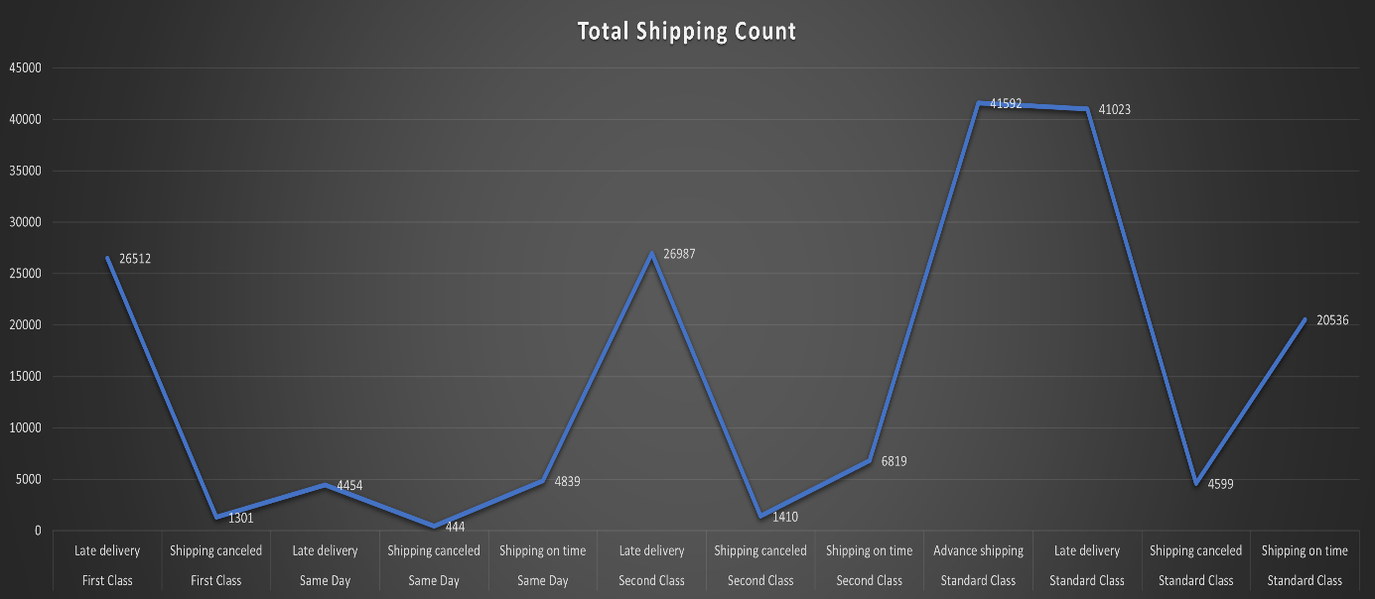

This graph shows the total shipping in different classes.

The profit value generated by the completed orders is 13,751,824.52 out of which only 5.17% is generated by class same day. Whereas the maximum profit is generated from standard class making up to 59.597% of the total.

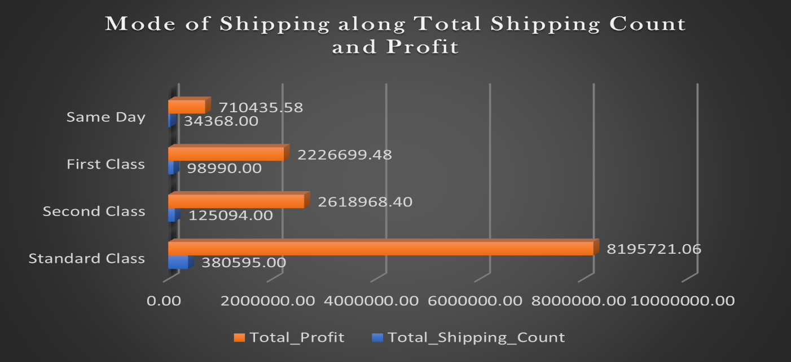

Graph shows the number of orders and profit along mode of shipping.

1. **Customer Segment**

Majority orders were placed by consumers. And home office has the minimum number of orders. Consequently, consumer is the customer segment that has generated maximum profit and sales.

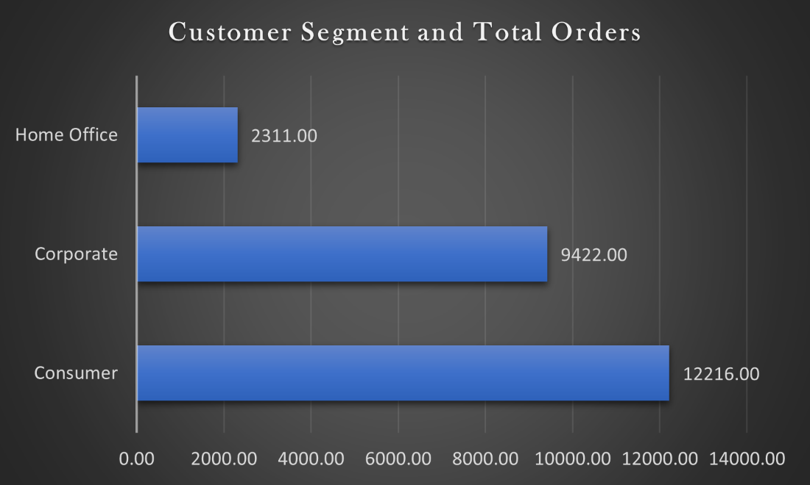

The graph shows number of orders along customer segment.

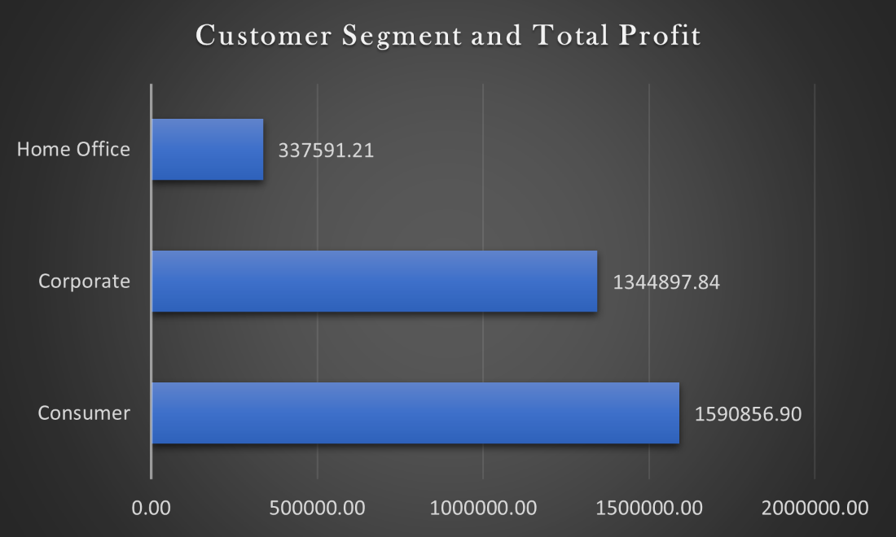

The graph shows total profit along customer segment.

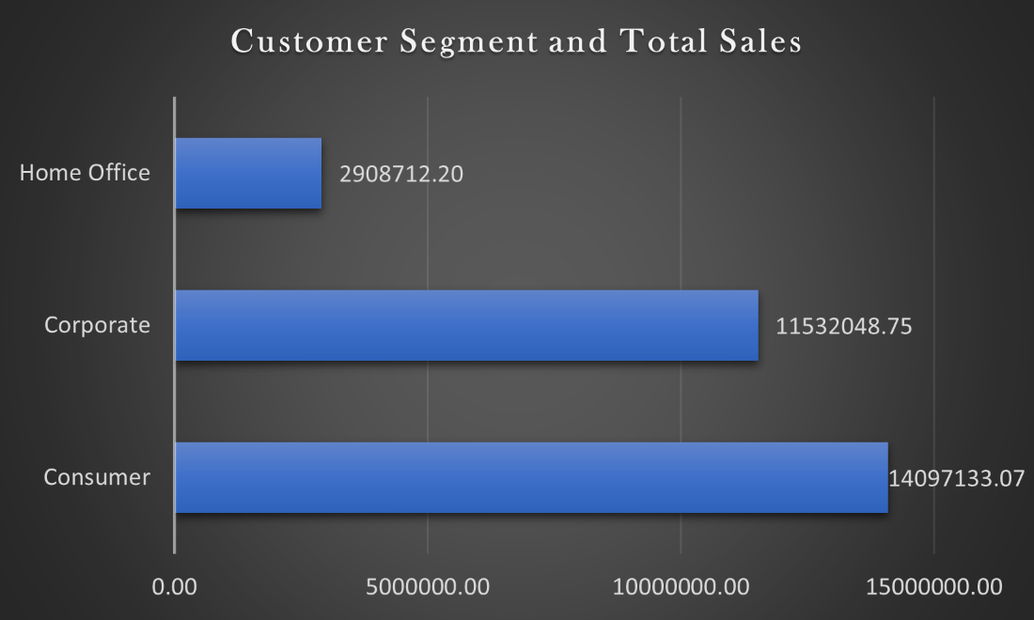

The graph shows total sales along customer segment.

Recommendations:

1. **Improve Supply Chain Efficiency:**

Streamline shipping processes and reduce late delivery risks to enhance customer satisfaction and sales. Logistics should be taken in loop and make arrangements for timely delivery specifically in Central America. Enable the best shipping mode to control late deliveries. Consumer segment should be more focused for timely delivery as they generated more profit and sales. Standard shipping mode is highly recommended.

1. **Tailor Marketing Strategies:**

Customize marketing efforts based on customer segments identified through RFM analysis to boost sales. Consumer segment has maximum sales and profit. Marketing campaigns should be more focused on consumer segment.

1. **Enhance Product Offerings:**

Identify underperforming products or categories and strategize improvements or discontinuation.

1. **Optimize Regional Focus:**

Concentrate resources on high-profit regions and markets to maximize profitability.

1. **Continuous Monitoring and Adaptation:**

Implement a continuous improvement process to regularly review and adjust strategies based on data-driven insights.